1. **What is joining two queries together based on columns called?**

Joining two queries together based on columns is called "merging queries." This operation allows you to combine data from two different queries by matching values in specified columns.

1. **What are the six different kinds of join operations that can be performed when joining queries?**

Inner Join: This type of join returns only the rows where there is a match in both tables based on the specified column(s).

Left Outer Join: Also known as a Left Join, this operation returns all the rows from the left table, and the matched rows from the right table. If there is no match, the result will contain null values for the columns from the right table.

Right Outer Join: Also known as a Right Join, this operation returns all the rows from the right table, and the matched rows from the left table. If there is no match, the result will contain null values for the columns from the left table.

Full Outer Join: This join operation returns all rows when there is a match in either the left or right table. If there is no match, the result will contain null values for the columns from the table that lacks the match.

Left Anti Join: This operation returns only the rows from the left table that do not have a match in the right table.

Right Anti Join: This operation returns only the rows from the right table that do not have a match in the left table

1. **What is it called when one query is added to another query?**

When one query is added to another query in Power BI, it's referred to as "appending queries." This operation allows you to combine the rows of one query with the rows of another query to create a single, larger query.

1. **Create a DAX expression with two columns, one containing names and a salary column with at least 5 entries.**

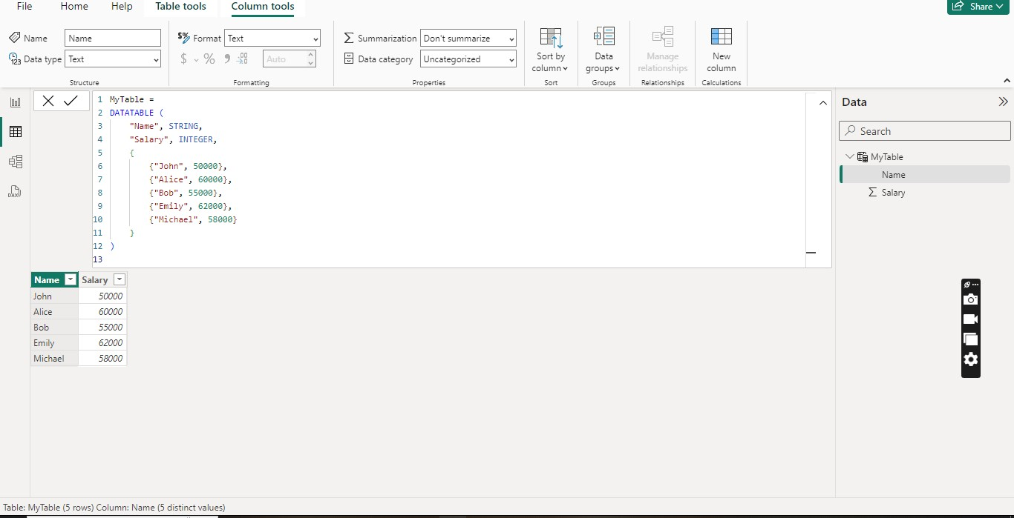

1. **Get the excel data file workbook into power BI, explain the relationship between tables.**

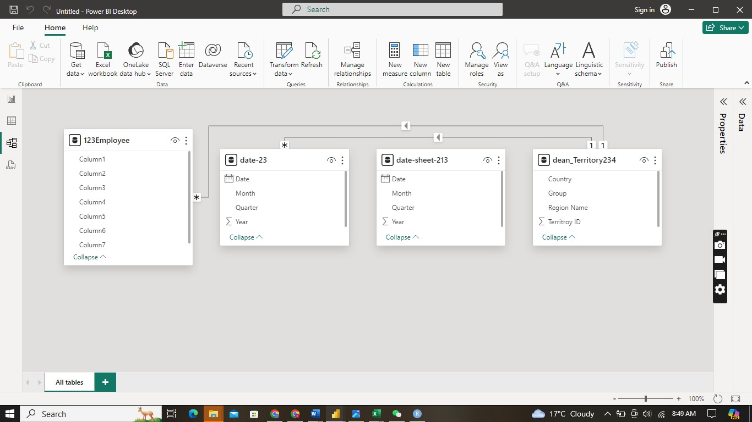

1. **Remove the rows which are null.**
2. 